# **Lesson 3: Periodic Trends and Predicting Properties of Elements**

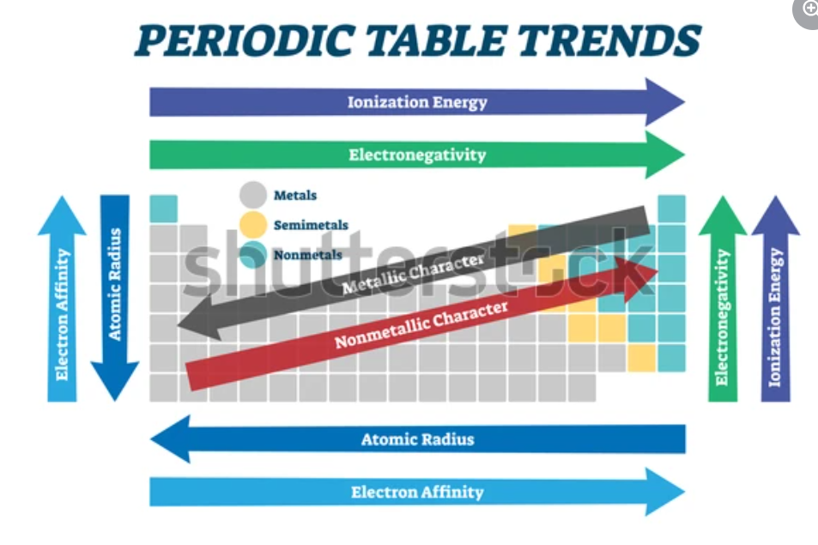

Figure 5.11. Periodic table showing periodic trends in fundamental properties

## <H1> **Essential Question**

How can we predict the reactivity and properties of elements based on their positions on the periodic table?

## <H1> **Big Idea**

The periodic table is not just a collection of elements but a powerful tool that reveals trends in fundamental properties.

## <H1> **Lesson Objectives**

By the end of the lesson, I will be able to:

* Recognize periodic trends, such as ionization energy, electronegativity, electron affinity, and atomic radius.
* Identify the factors that cause these periodic trends.
* Predict the properties of an element, including reactivity and stability, based on its location in the periodic table.

## <H1> **Curiosity Corner**



Figure 5.12. A tractor with salt bucket: Deicing the street

In northern regions, road salts are used to melt ice on streets during winter. Common salts like sodium chloride, magnesium chloride, and calcium chloride contain different elements, and each salt contains a common anion, which is chloride. These salts differ in many chemical properties conferred by the electronegativity, ionization enthalpy, and other properties of the elements. These atomic properties are predictable using periodic trends.

## <H1> **Key Vocabulary**

Periodic trends- Regular patterns or variations in element properties (e.g., atomic size, ionization energy) across the periodic table.

Atomic radius- The average distance from the nucleus to the outermost electron, indicating the size of an atom.

Electron affinity- The amount of energy released when an isolated gaseous atom gains an electron, reflecting its tendency to accept electrons.

Electronegativity- A measure of an atom's ability to attract electrons in a chemical bond, influencing molecule polarity.

Ionization energy- The energy required to remove an electron from an isolated gaseous, indicating its reactivity and ability to form cations.

## <H1> Ignite: **Periodic Trends**

Direct Instruction: The elements organized in the periodic table reveal the patterns of their fundamental properties called periodic trends. These trends can be observed by looking at how certain properties change as you move across a period (left to right) or down a group (top to bottom). Understanding these trends assists scientists in predicting elements’ behavior, reactivity, and stability based on their positions on the table.

By understanding these trends, we can predict why elements like sodium are highly reactive and why other elements, like helium, are not.

## <H1> **Progress Check 1**

What are periodic trends, and how do they help scientists in predicting the properties of elements based on their positions on the periodic table?

## <H1> **Pathfinder: Exploring General Periodic Trends**

**Materials Required:**

Periodic table chart

Colored markers

Worksheet for identifying trends (e.g., atomic size and metallic character)

**Procedure:**

* Observe elements across Period 3 (from sodium to argon) on the periodic table. Note how the elements are placed.
* Use markers to highlight changes in electronic configuration and metallic character as you move across the period and down the group, say Group 1 (from lithium to cesium).
* Discuss how these general trends, such as metallic character down the group, help to predict the behavior of elements.

## <H1> **Progress Check 2**

1. How does atomic size change as you move across a period from left to right? Why does this trend occur?
2. Why do elements on the left side of the periodic table generally exhibit more metallic properties compared to those on the right? Explain your reasoning.

## <H1> Lightbulb: **Trends in Atomic Radius**

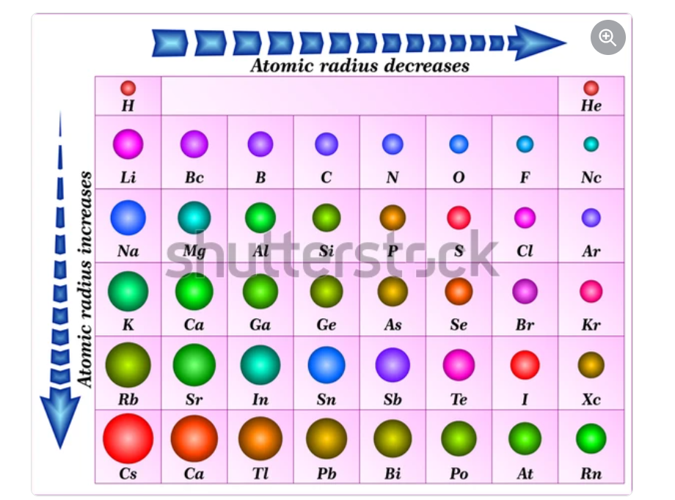

Figure 5.13. Trends of atomic radius in the periodic table

The atomic radius is the distance from the center of the nucleus to the outermost electrons. Understanding atomic radius helps to explain how easily an element can lose or gain electrons.

**Trend:**

Across a period (left to right), the atomic radius decreases. This is because as you move from left to right of the periodic table, more electrons and protons are added to the outermost shell and nucleus, respectively. The electrons are added to the fixed outermost shell until the octet is filled. The positive charge increases, pulling the electrons closer, and hence makes the atom smaller in size.

Down the group (top to bottom), atomic radii increase because in each element one additional electron shell is added, which makes the atoms larger.

Sodium, magnesium, and calcium are all metals found in the topmost part of Groups 1 and 2. Their larger atomic radii than nonmetals on the right side of the periodic table. This is because of the difference in the number of protons in the nucleus and hence results in higher effective nuclear charge. The elements on the left side contain a smaller number of electrons in their outermost shell, which makes it easier to lose electrons from the valence shell. On the other hand, due to the highly effective nuclear charge, elements on the right can accept electrons. Hence, chloride easily accepts electrons to fulfill its octet. This is why the elements of the left side form bonds with chloride ions and create salts, which are used to melt ice.

## <H1> **Trends in** **Ionization Energy**

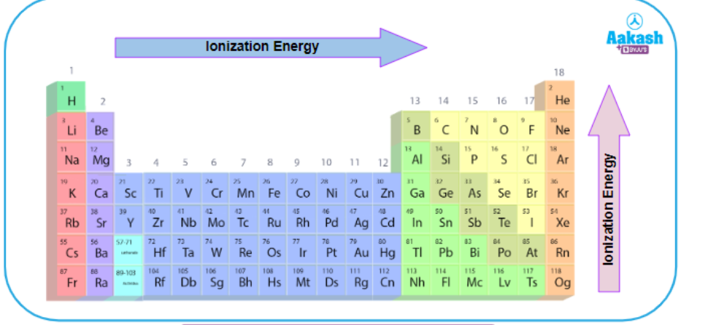

Figure 5.14. Trends in ionization energy

Ionization energy is the amount of energy required to remove an electron from an atom in its isolated gaseous state. It gives us insight into how easily an element can lose its outermost electron(s).

**Trend:** Ionization energy is inversely proportional to the atomic size.

Across a period, ionization energy increases because the attraction between the nucleus and electrons becomes stronger and increases the effective nuclear charge. As a result, it becomes difficult to remove an electron from its outermost shell.

Down a group, ionization energy decreases. An extra electron shell is added on moving down the group. The distance between outer electrons and nucleus increases, resulting in less attraction between them. So, it is easier to remove a valence electron.

The low ionization energy of metals like sodium, magnesium, and calcium means they can easily lose their valence electrons, forming positively charged ions, or cations. It makes them reactive and ideal for forming bonds with anions such as chloride ions.

### <H2> **Progress Check 3**

1. Why is the ionization energy of potassium lower than that of sodium?
2. How would the reactivity of metals change if their ionization energy were to increase significantly across a group? Explain your reasoning.

## <H1> **Trend in** **Electron Affinity**

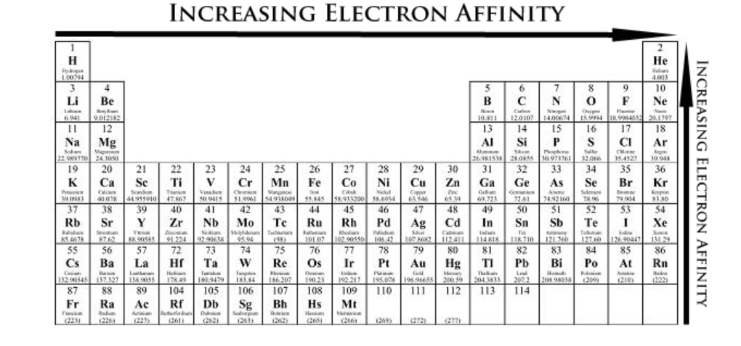Figure 5.15 Trends in electron affinity

Electron affinity is the amount of energy released when an isolated gaseous atom gains an electron in its outermost shell. It helps to predict which elements are likely to gain electrons during reactions.

**Trend:**

Across a period, electron affinity value generally becomes more negative. This is because on moving of the decrease in atomic size and increase in the nuclear charge.

Down a group, electron affinity becomes less negative. Because the size of the atom increases and

the added electron would be farther from the nucleus.

### Chlorine has a high electron affinity, meaning it can easily gain an electron to complete its outer shell. This makes chlorine effective at bonding with elements that tend to lose electrons, like metals such as sodium. The trend of electron affinity in the periodic table helps predict which elements are likely to form bonds and how stable those bonds might be.

### <H2> **Progress Check 4**

1. What does it mean if an element has a high electron affinity?
2. Explain how the trend in electron affinity across a period helps predict the stability of the compounds formed by elements in that period.

## <H1> **Trends in** **Electronegativity**

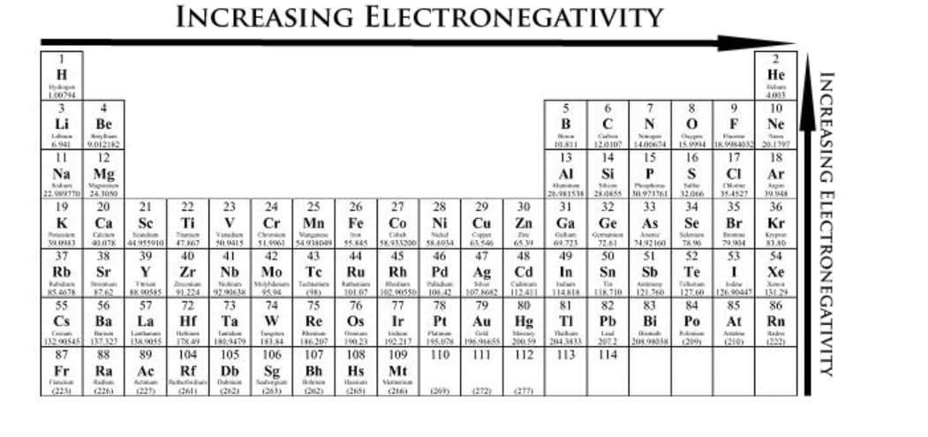Figure 5.16 Trends of electronegativity in the periodic table

Electronegativity is a measure ofan atom's ability to attract the electrons that bond the atom to another atom. There are several ways to calculate the electronegativity of an element; one way is the average between its ionization and electron affinity energies. Elements with high electronegativity, like fluorine, are more likely to pull the bonding electrons toward themselves when forming bonds.

**Trend:**

Across a period, electronegativity increases because atoms with more protons attract electrons more strongly.

Down a group, electronegativity decreases as the atomic radius increases, which lowers the effective nuclear charge, weakening the nucleus’s attraction to electrons of other atoms.

### <H2> **Progress Check 5**

1. Why does electronegativity increase across a period on the periodic table?
2. Predict how the difference in electronegativity between sodium and chlorine affects the type of bond formation. Explain your answer.

## <H1> **Periodic Trends and Predicting Properties**

### Understanding and predicting trends like atomic radius, ionization energy, electronegativity, and electron affinity in the periodic table makes it easier for students, researchers, and scientists to see how elements might act. For example, sodium has a large atomic radius and low ionization energy, so it easily loses electrons. On the other hand, chlorine has high electronegativity and electron affinity, so it easily gains electrons. This difference causes sodium and chlorine to form a stable compound. By knowing these patterns, you can guess how other elements might act and use them in real-life applications.

### <H2> **Progress Check 6**

What elements would be more reactive?

1. Elements with a large atomic radius or with a small atomic radius? Explain.
2. Large ionization energy elements or small ionization energy elements? Explain.

## <H1> **Power Up**

The Questioneer Icon

Reflect on the following prompts to think critically about the content and develop meaningful questions for inquiry about **Periodic Trends and Predicting Properties of Elements:**

* The gradual atomic number increasing trend in the periodic table reveals the patterns of the fundamental properties of an element that can predict its behavior.
* Reactivity and stability are influenced by factors like ionization energy and atomic radius.
* The periodic table helps you to understand why some elements are more reactive than others.
* By studying trends, you can predict correct trends or changes in the properties of elements.

## <H1> **Lesson Check**

1. How can atomic radius and ionization energy be correlated? Explain how a large atomic radius affects ionization energy.
2. Compare the electronegativity of elements residing in Group 1 and Group 17. Why are elements in Group 17 generally more electronegative than those in Group 1?
3. Predict how the properties of an element would change if it were to be moved from Period 2 to Period 3 but stayed in the same group. Explain the reasoning for your answer.
4. Why does electron affinity become less negative as you move down the group on the periodic table?

## <H1> **Beyond the Lesson**

Understanding the periodic trends of fundamental properties enables scientists to predict the behavior of elements in various situations. For example, knowing a certain metal that has low ionization energies helps in developing batteries, where these metals can easily release electrons to generate power. Similarly, elements with high electronegativity are useful in creating strong chemical bonds for industrial applications. The alkali metals are highly reactive (lithium, sodium, etc.), which makes them best fitted in the applications of pharmaceuticals and fireworks. The periodic trend of melting and boiling point assists in pointing out that the element has high melting and boiling points for high-temperature applications like in bulb filaments (Tungsten). The bond length and strengths can be predicted by focusing on the atomic radius trend in the periodic table, which could depict that stronger bonds are suitable for application in adhesive and polymer industries. Fluorine-based materials are used in such industries in huge amounts due to the formation of stronger bonds rather than longer bonds. These insights from periodic trends are essential for everything from designing electronics to producing new materials.